|  |  |  |  |  |
| --- | --- | --- | --- | --- |
| **Nama** | **: Risky Fauziah** |  | **Mata Kuliah** | **: Praktikum Jaringan Komputer** |
| **NIM** | **: 171011450082** |  | **Tugas** | **: Pertemuan ke-6 (B)** |

**B) Konfigurasi Router-Access Point (Non-Kabel)**

**1) Konfigurasi Manual IP Address**

a)

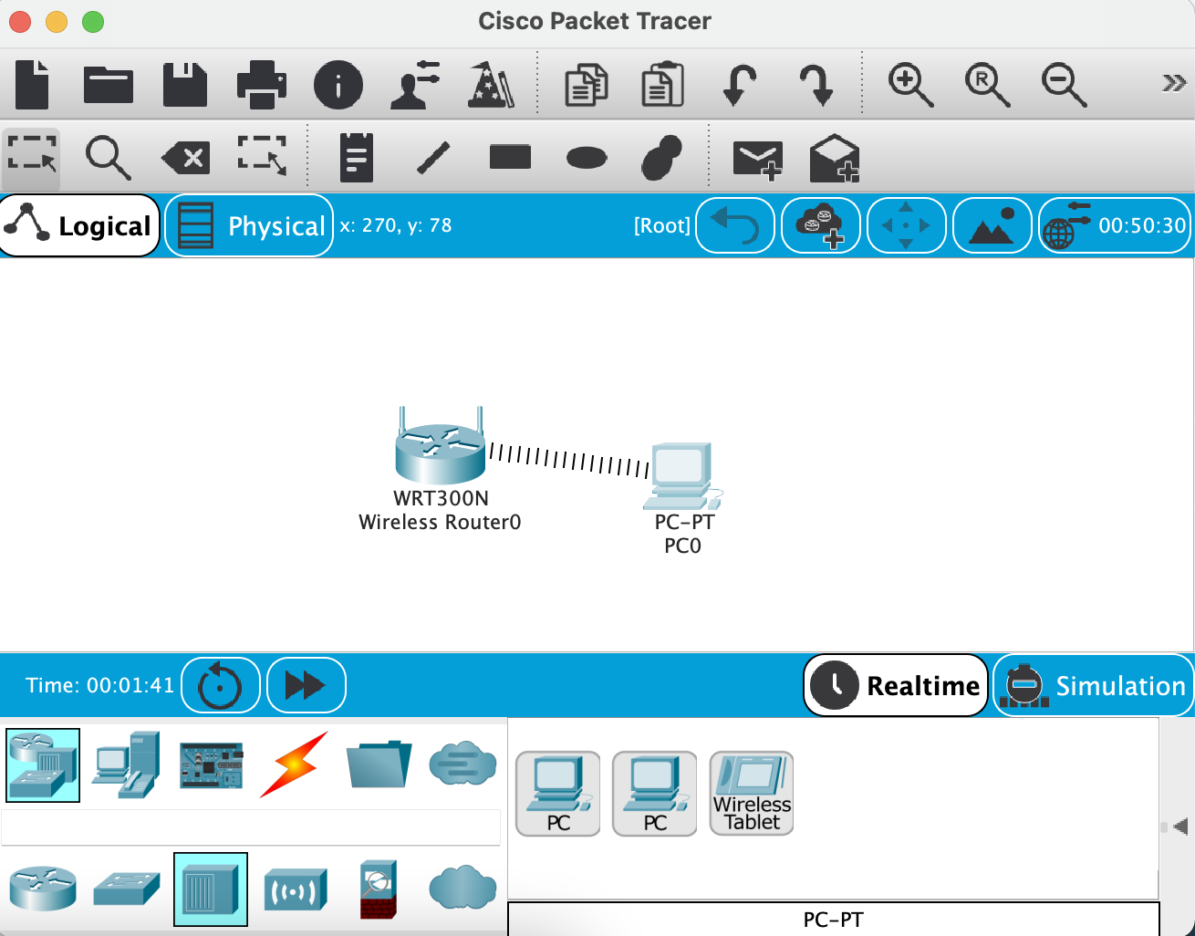

b)

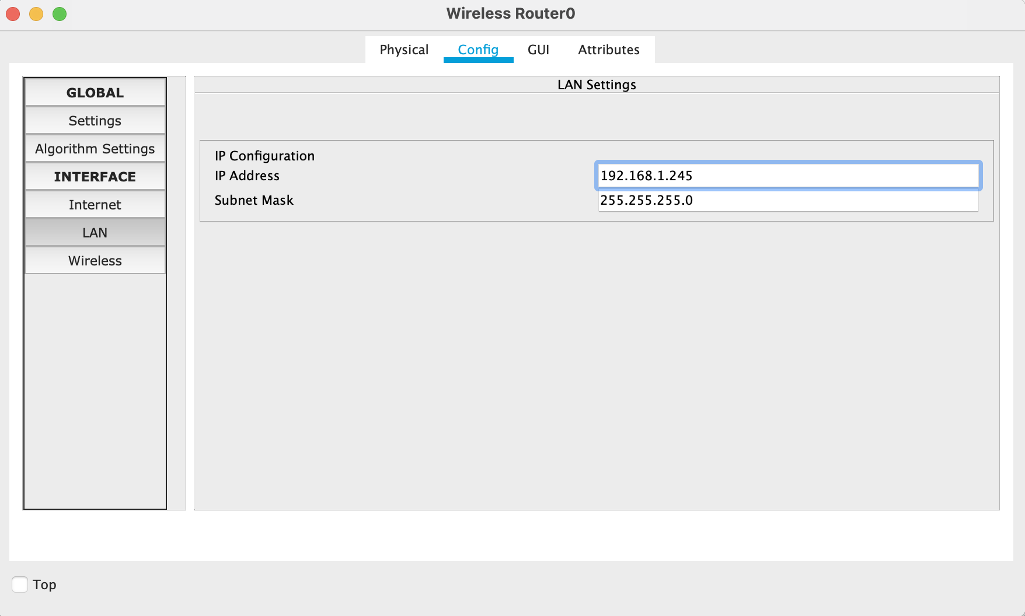

c)

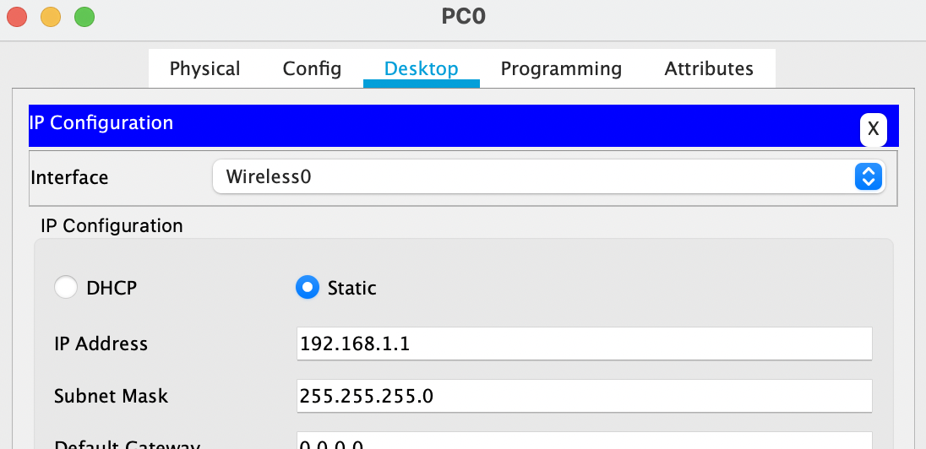

d)

PC0

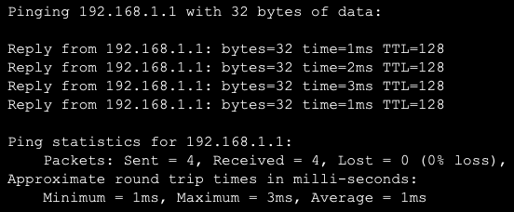

Wirelees Router0

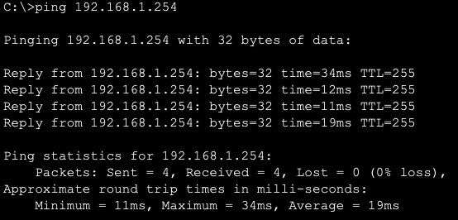

e)

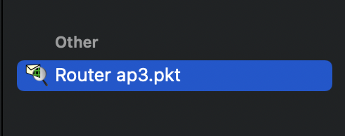

**2) Konfigurasi Dynamic IP Address**

**a)**

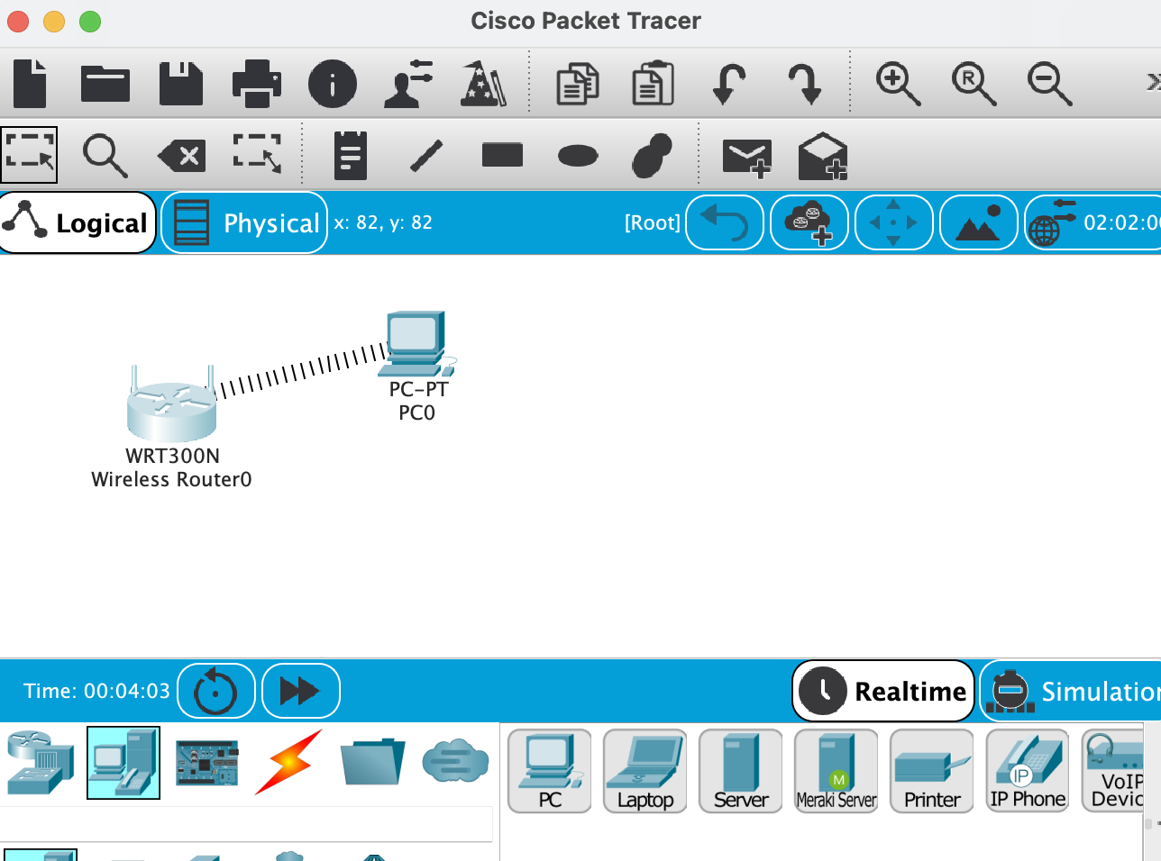

b)

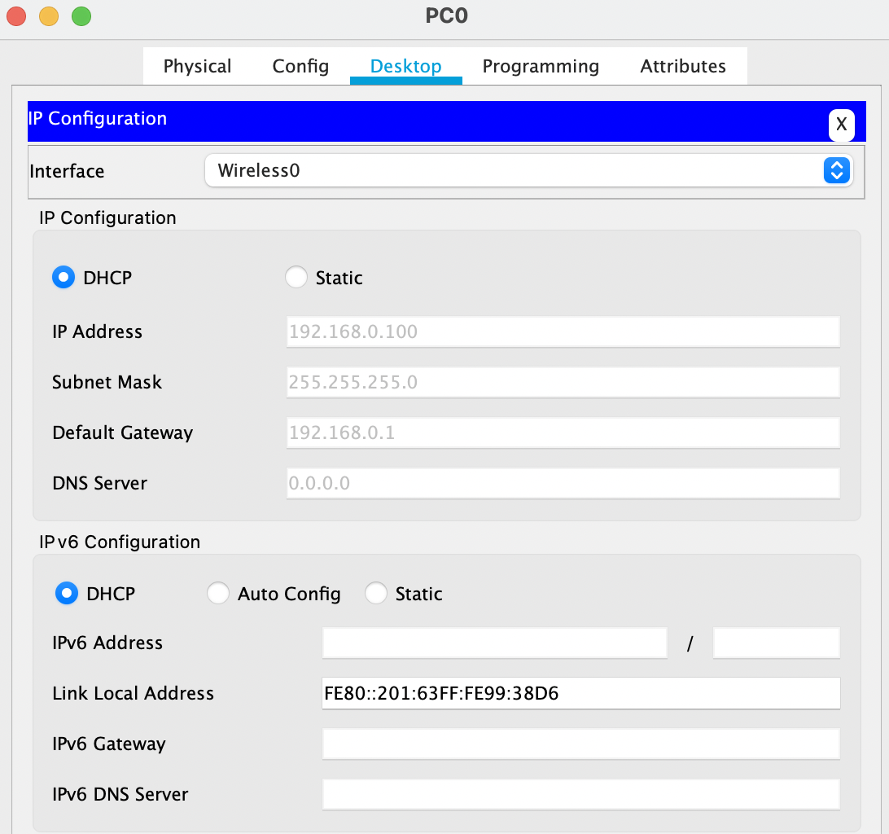

c)

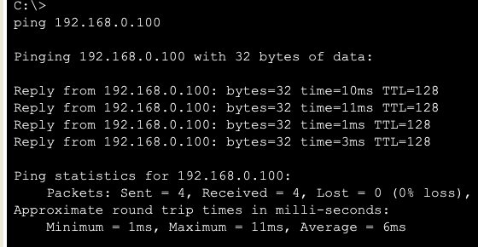

d)



**c) Scurity Router-Access Point**

**a)**

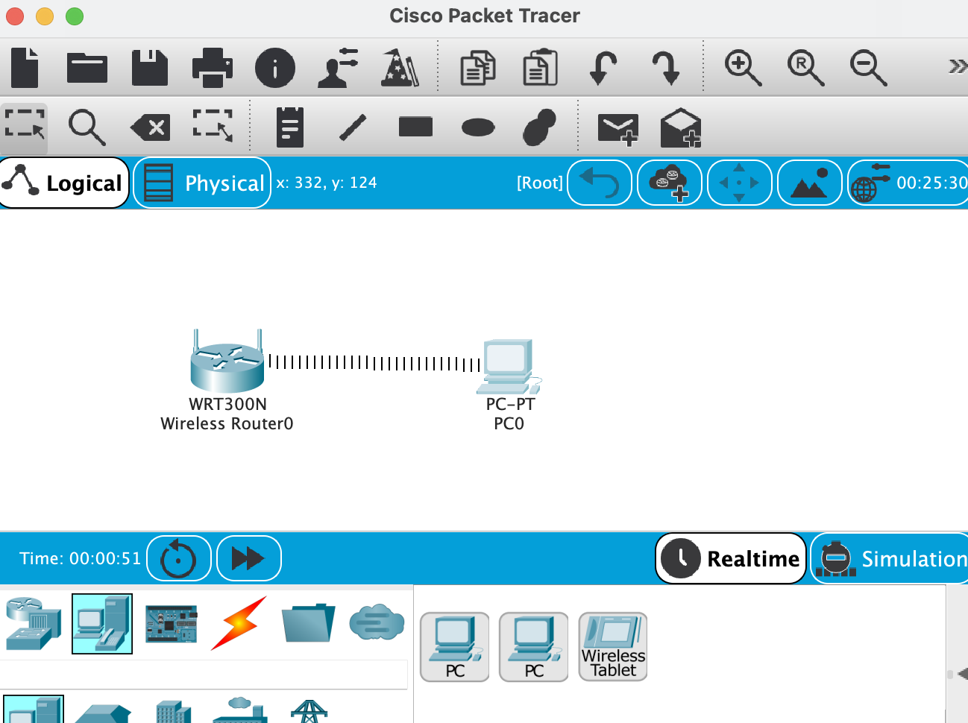

**b)**

**c)**

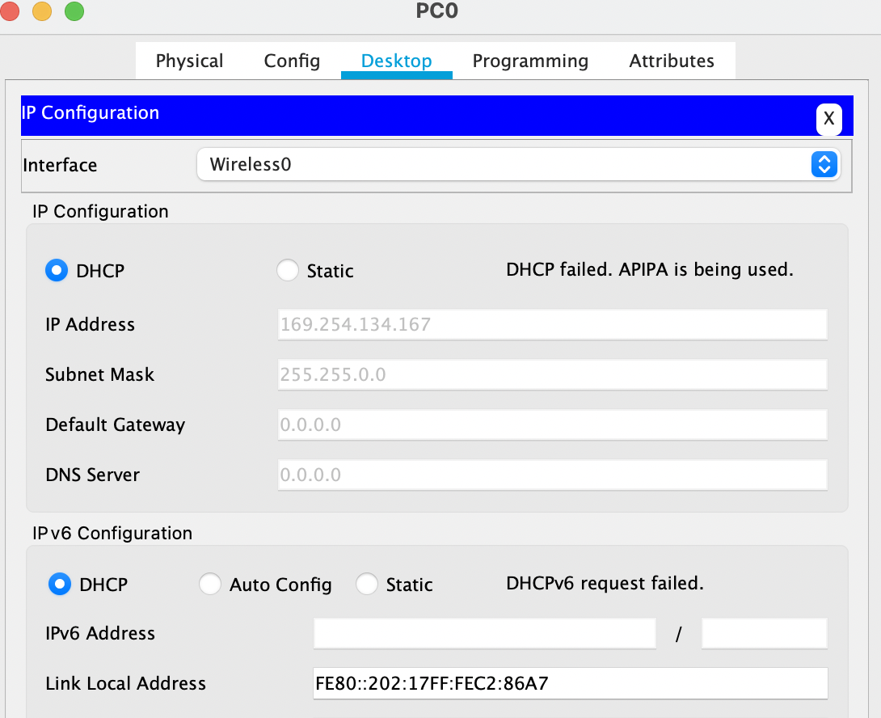

**d)**

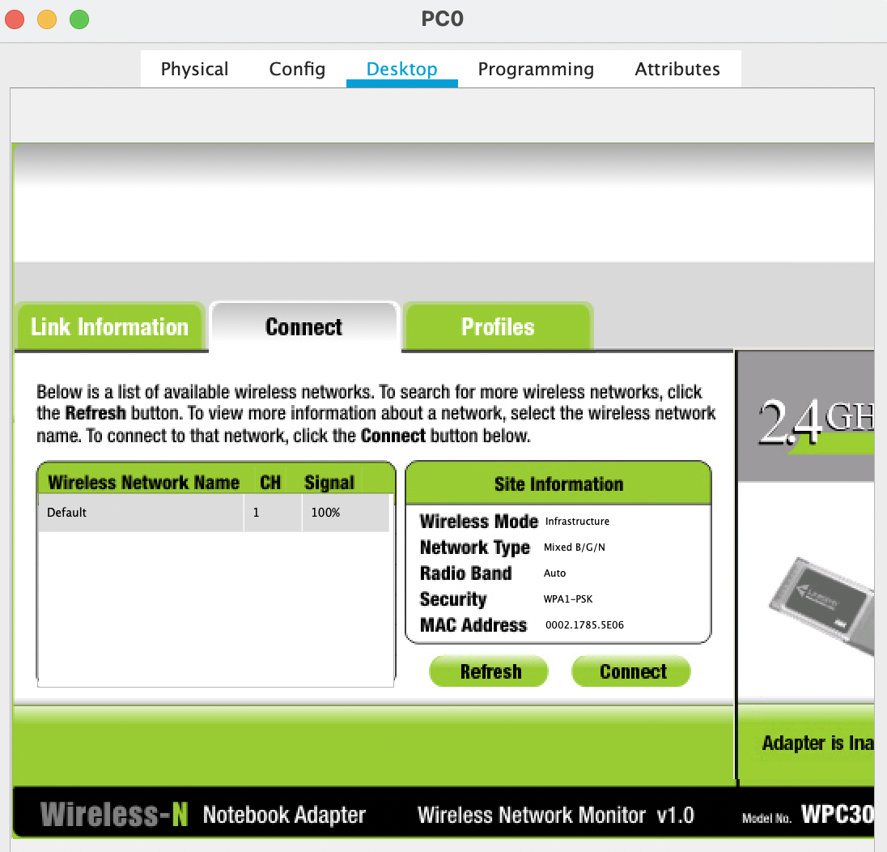

**e)**

**f)**

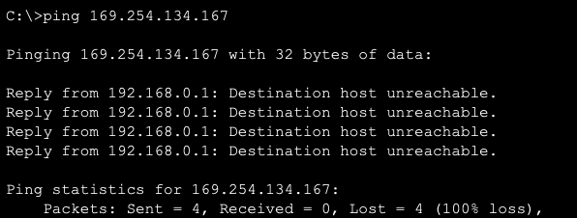

**g)**

